# ['Law & Order's Christopher Meloni Expects 'a Lot of Emotion' When Stabler & Benson Reunite](https://www.tvinsider.com/941933/law-order-svu-benson-stabler-reunion-christopher-meloni/)

[***Meredith Jacobs***](https://www.tvinsider.com/author/meredith-jacobs/) • July 16, 2020 10:00 am

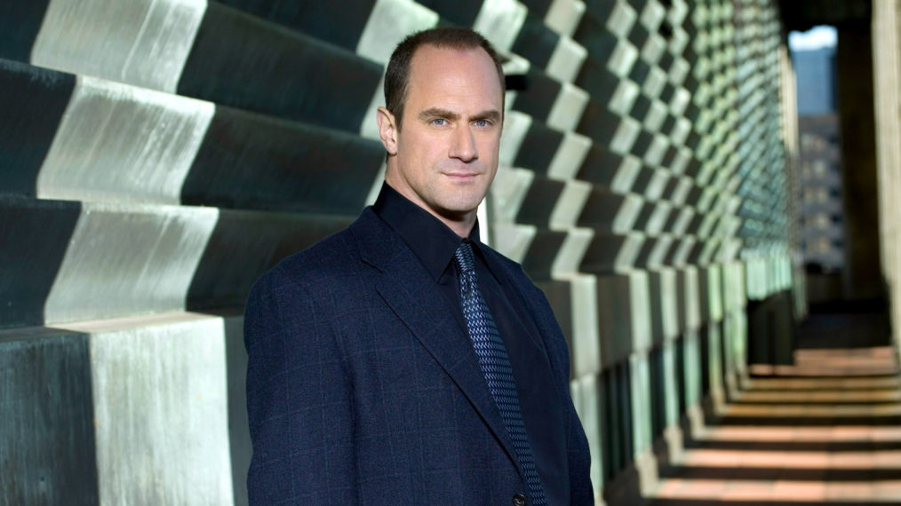Q&AVirginia Sherwood © NBC / Courtesy Everett Collection

It's been almost 10 years, but [Christopher Meloni](http://tvinsider.com/people/christopher-meloni) will be stepping back into Elliot Stabler's shoes for NBC's 2020-2021 season.

Joining [*SVU*](http://tvinsider.com/show/law-order-svu) in the Thursday night lineup is the new spinoff, [*Law & Order: Organized Crime*](http://tvinsider.com/show/law-order-organized-crime), following Meloni's character as he returns to the NYPD after suffering "a devastating personal loss" to lead a unit battling organized crime. And with his return to that world comes an inevitable reunion with his former partner, (now Captain) Olivia Benson ([Mariska Hargitay](http://tvinsider.com/people/mariska-hargitay)).

Here, Meloni discusses returning to Dick Wolf's world and speculates about what to expect from that Stabler-Benson reunion.

[**SEE ALSO**](https://www.tvinsider.com/817517/law-order-svu-best-episodes-seasons-1-20/)

### [**10 Standout Episodes From the First 20 Years of 'Law & Order: SVU' (VIDEO)**](https://www.tvinsider.com/817517/law-order-svu-best-episodes-seasons-1-20/)

As Olivia Benson and the SVU take down more baddies in Season 21, a look at memorable episodes from the first two decades.

**Why is now the right time for you to return to Elliot Stabler?**

**Christopher Meloni:** There are certain things that have transpired in my life that made me more comfortable in going back into this world.

**What can you say about where Stabler is now that makes it the right time for him to return to the NYPD and lead this unit?**

There's a lot to unpack here. A lot of fans want to know, 'What the heck? Why the abrupt leaving? Why no phone call to Olivia, and by the way, where have you been?' I hope they're along for the ride of, what is this show, what is this world that Elliot is inhabiting, and by the way, we left Elliot 10 years ago — where is he in his life, emotionally, mentally? How has he evolved?



(Virginia Sherwood © NBC / Courtesy Everett Collection)

Also, which is very topical, we're really living in a very different world than we were 10 years ago. That needs to be addressed. I think it will be. It's just a new world that you find a character you knew from the olden days back in. You have to address that.

**Speaking of Elliot and Olivia and everything they have to discuss, how do you think he's going to handle that reunion, based on where he is? The "devastating personal loss" he suffered has to affect how he relates to those he knew, right?**

Yes, I guess. And I only say it like that because what I feel and what I think personally, I can't really speak of because it'll all be reflected in the words I'm given and the circumstances I'm given, so it's really up to the writers. I could think of a thousand and one ways it could be handled. As soon as I see what the showrunners, the powers that be, have in mind for the tone, the timber, the time and place of how they unite and under what circumstances... As you can imagine, it's going to be heavily-laden with 10 years of stuff and a lot of emotion, not that it'll be an emotional scene.

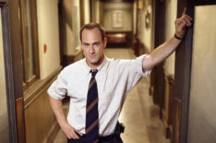[**SEE ALSO**](https://www.tvinsider.com/930834/elliot-stabler-law-order-svu-spinoff-christopher-meloni/)

### [**Stabler Is Back! Inside Christopher Meloni's 'Law & Order: SVU' Spinoff**](https://www.tvinsider.com/930834/elliot-stabler-law-order-svu-spinoff-christopher-meloni/)

How hopeful should fans be about seeing Stabler and Benson together again in a crossover?

... I really appreciated that they didn't put the foot on the gas pedal too hard, that our relationship and the scenes that we had were very measured out appropriately. I personally think that because there was so much gray in there and so much unsaid between these two people, it gave it such a profoundly larger life and thus has allowed it to withstand 10 years of being separated. It still lives and people are still curious about it, and it evolved over time. It was very complicated.

**Should we read into *Organized Crime* taking over the 10pm time slot from *SVU* in terms of the content we should expect? Darker?**

I'll say this, I hope they utilize the 10pm slot to not shave down edges that you need to for other time slots, but to me, that does not equate, "Oh, good, we get to get away with violence." To me, that's not the cornerstone of enhanced drama. I just hope what you said: "darker." I think people tune in to these shows to see a stark aspect of life and good storytelling and complicated storytelling. I like more adult-themed shows, so yes, I hope so, but I just don't want it to be equated with "we get to go out and kick ass." I don't think that's the timber of the times.

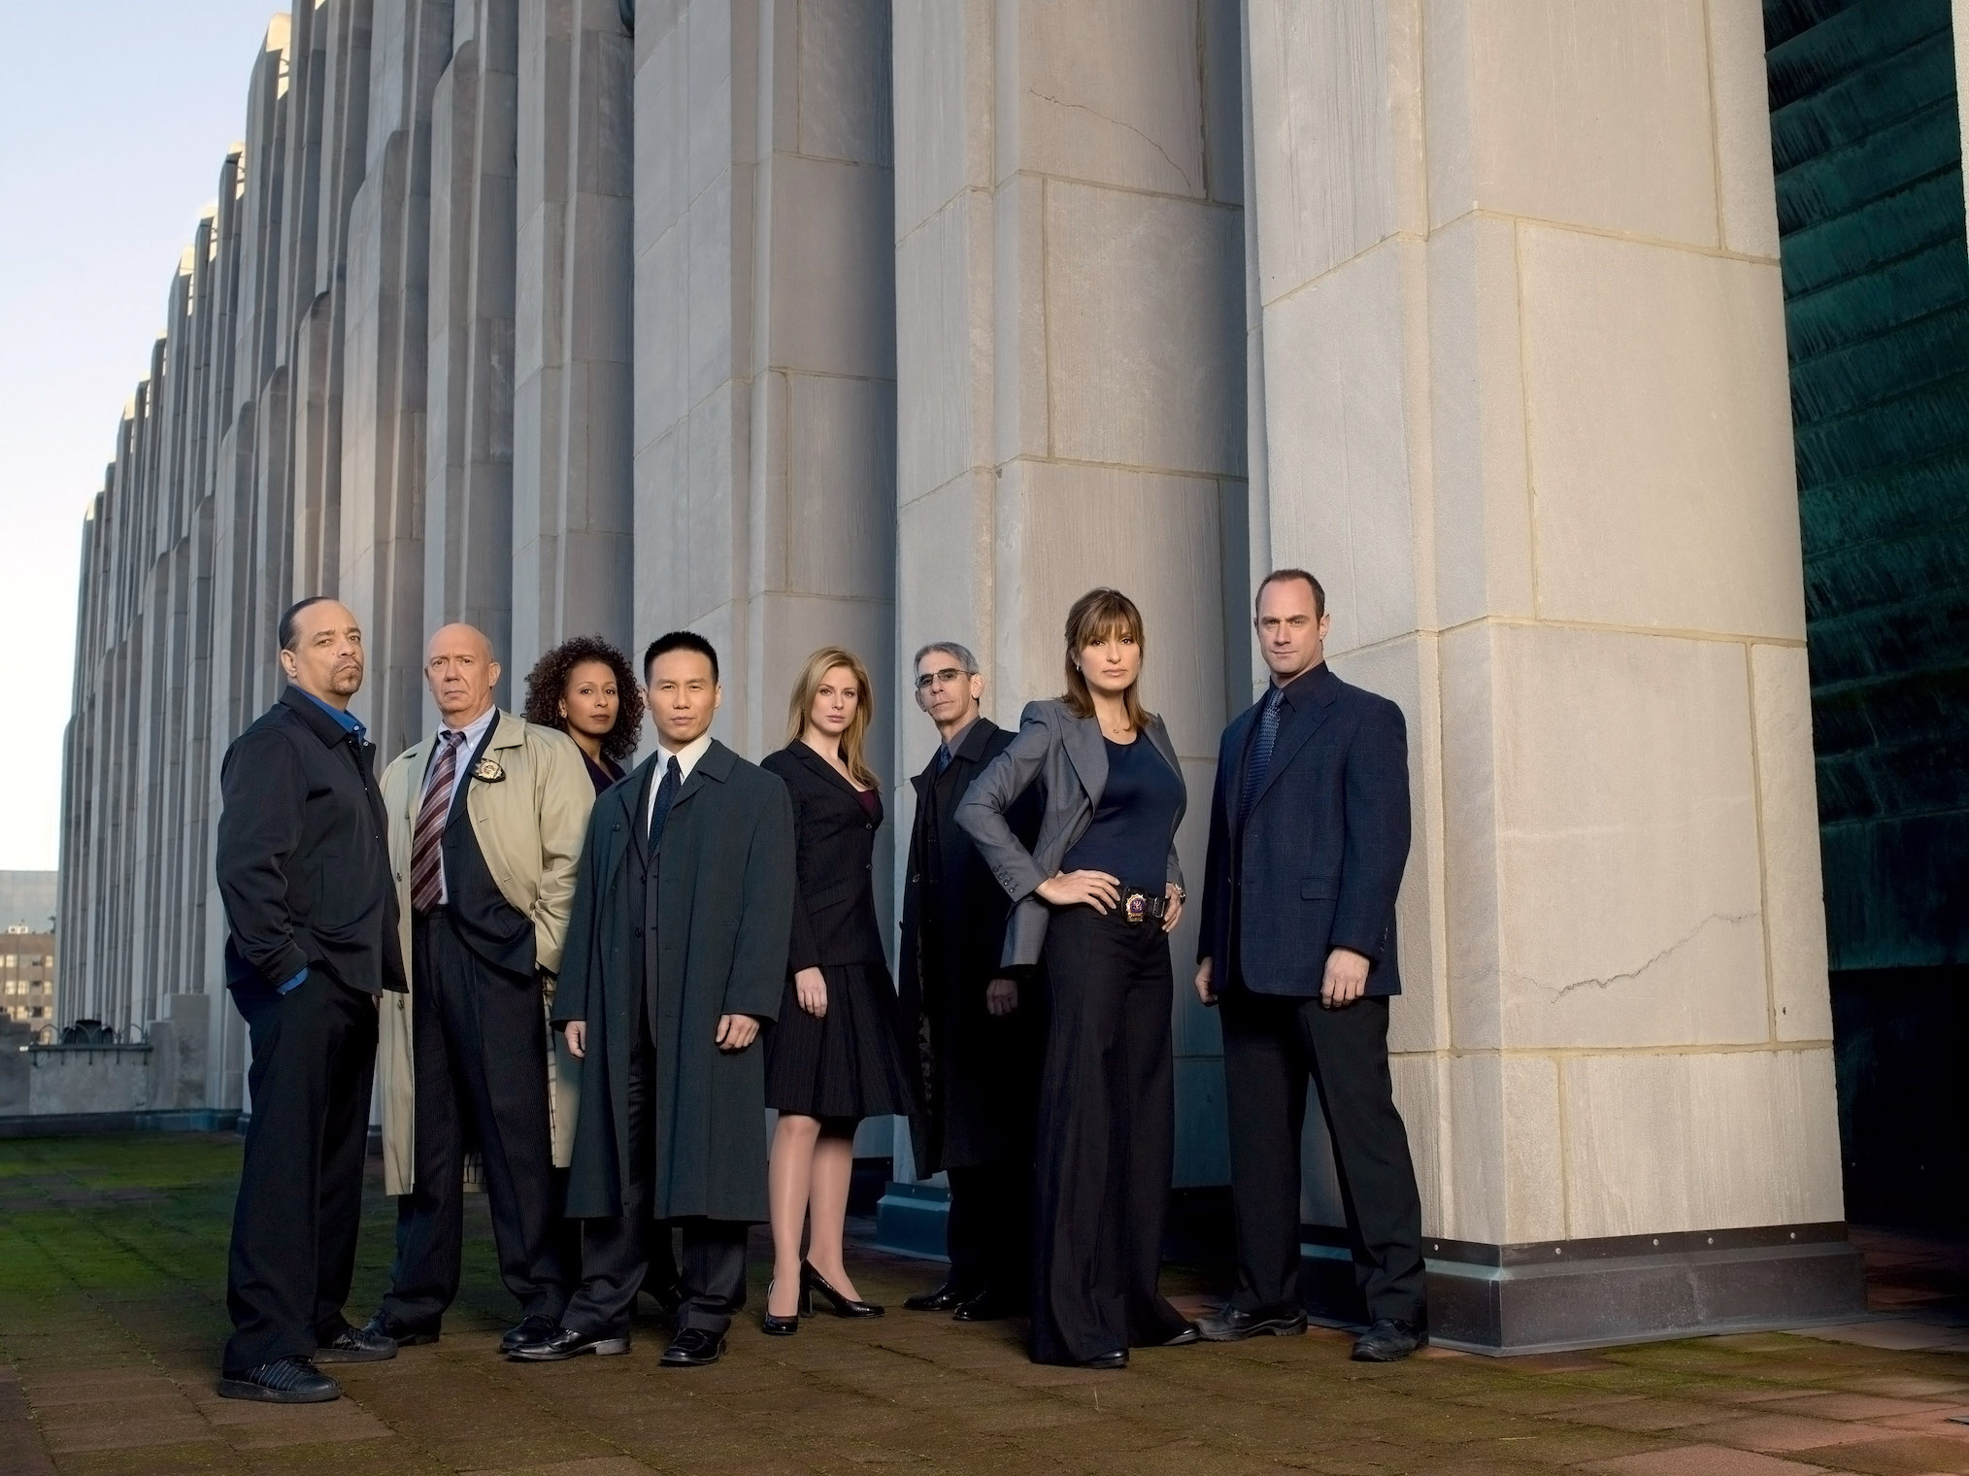

*Law & Order: SVU* Cast in Season 8 (Virginia Sherwood © NBC / Courtesy Everett Collection)